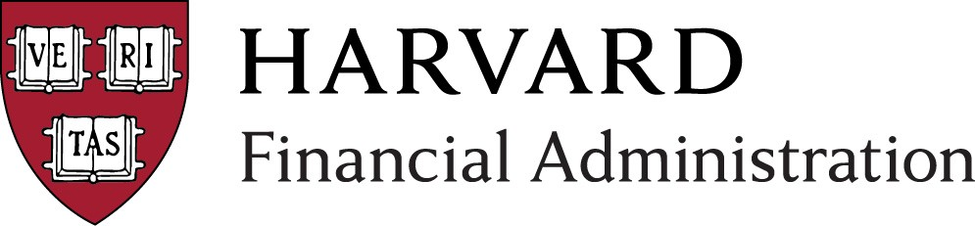
Financial Administration
FY 16 Processes & Deliverables Calendar
Q4
2015 Q1
2016 Q3
Q2
Follow-up Range

Activity Range
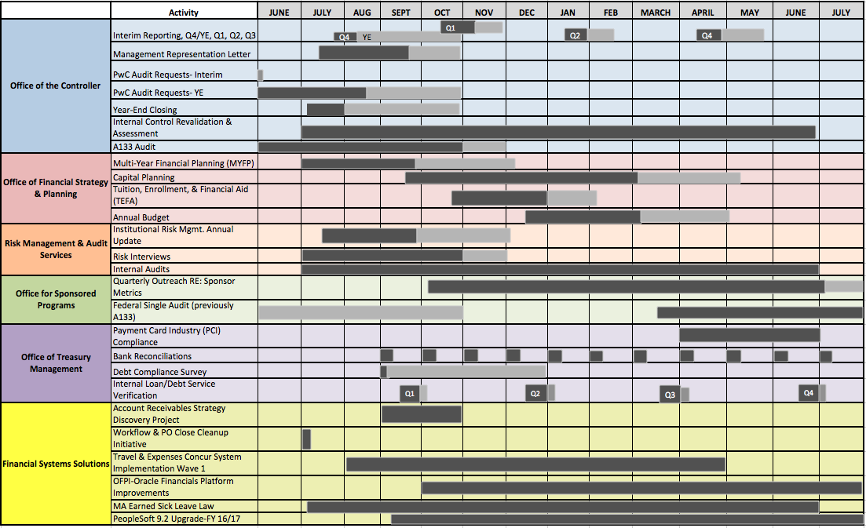
Reference guide only. Dates subject to change without notice.
Updated: October 2015
Financial Systems Solutions FY16 Update
Release Calendar

Activity | Anticipated Start Date | System Outage | Go Live Date | Close Date
GMAS Release (GMAS 2.0) | 12/11/2015 | 12/12/2015-12/13/2015 | 12/14/2015
GMAS Release (GMAS 2.0) | 3/1/2016 | TBD | TBD
GMAS Release (GMAS 2.0) | 6/1/2016 | TBD | TBD
ESTR Product Path Release | 10/16/2015 | 10/16/15-10/18/2015 | 10/19/2015
HUBS Upgrade Project | 7/1/2015 | 11/6/2015-11/8/2015 | 11/9/2015 | 11/30/2015
PeopleSoft Release 43.0 | 12/4/2015 | 12/7/2015
PeopleSoft Release 44.0 | 4/15/2016 | 4/18/2016
Oracle EBS Release FINDINI 4.0.8 | 6/1/2015 | 10/24/2015-10/25/2015 | 10/26/2015
Oracle EBS Release FINDINI 4.0.9 | 11/1/2015 | TBD-March/April 2016 | TBD-Mar/Apr. 2016 | TBD
Disabling of Accounts Payable, Accounts Receivable  and Cash Management Reports in CREW |  |  | 11/1/2015
Grants Management OBI Dashboards | 10/21/2015-pilot |  | 11/9/2015- University-wide

Appendix: Dates and Glossary of Terms FY16 Update

Office of the Controller:
Activity | Anticipated Start Date | Anticipated Due Date | Description
Interim Reporting | Q4/YE: 7/27/15 Q1: 10/16/15  Q2: 1/15/16  Q3: 4/14/16 | Q4 / YE: August 5  (follow-­‐up through October 29)  Q1: November 5  (follow-­‐up through November 27)  Q2: January 29  (follow-­‐up through February 19)  Q3: April 27  (follow-­‐up through May 20) | The quarterly process during which Schools/Units analyze material variances in their interim operating results; they compare: 1) their year-­‐to-­‐date performance vs. year-­‐to-­‐date performance of the prior year, 2) their year-­‐to-­‐date performance vs. the budget, and 3) their projection for the current financial year vs. the budget / most recent quarter. Schools also comment on year-­‐over-­‐year variances in balance sheet items.
− Q1 quarterly reporting template & checklist (Year over Year fluxes -­‐ balance sheet flux, statement of changes in net assets, Internal control checklist) | 10/16/15 | 11/5/2015  (follow-­‐up through 11/27/2015) | ""
− Q2 quarterly reporting template  & checklist | 1/15/16 | 1/29/2016  (follow-­‐up through 2/19/2016) | ""
− Q3 quarterly reporting template  & checklist | 4/14/16 | 4/27/2016  (follow-­‐up through 5/20/2016) | ""
− YE quarterly reporting template  & checklist | 7/27/15 | 8/5/2015**  (follow-­‐up through 10/29/2015) | **The YOY flux analysis is due 8/5. Budgeting and forecasting materials due 8/21
Management Representation Letter | 7/17/15 | 9/23/2015  (follow-­‐up through 10/29/2015) | The annual process during which Senior Management from each School/Unit declares in writing (to FAD and ultimately to the external auditor), to the best of their knowledge, that the financial statements and other presentations are sufficient and appropriate and without omission of material facts to the financial statements.

PWC Interim Audit Requests PWC YE Audit | 3/16/2015  6/20/2015 | 5/2/2015  (follow-­‐up through 5/22/2015)  8/17/2015  (follow-­‐up through 10/29/2015) | The University is required to have an annual audit of its financial statements. The financial statement audit is done by external auditors, PricewaterhouseCoopers, LLP (“PwC”). This is the annual process during which requests are made to the Schools/Units to provide financial information to PwC, which is used in their audit of the University’s financial statements. PwC may also request to do work at a School/Unit site. The date the financial information is requested will depend on whether the request is for the interim audit or the year end audit.
Year End Closing | 7/2/15 | 7/31/2015  (follow-­‐up through 10/29/2015) | The annual process during which the University completes its financial statement audit and issues its financial report for the fiscal year. This process also includes the final period for processing accounts payable invoices as well as a comprehensive analysis and review of the University’s commitments and contingencies. Analysis is performed to compare finalized results with budgets and interim forecasts.
Internal Control Revalidation  & Assessment | 7/1/15 | 6/30/16 | Some Schools/Units will be asked to validate that key controls from existing internal control processes are operating as designed and to identify any modifications to key controls. Additionally, the OC will continue to assess internal controls for additional business cycles, during which Schools/Units will be expected to participate in internal control discussions, documentation and implementation. The OC will work with financial managers to discuss what financial cycles will be chosen for assessment.
A133 Audit * | 6/1/15 | 10/30/2015  (follow-­‐up through 11/30/2015) | *The A133 Audit includes awards for both Financial Aid and Research Grants. Schools are audited on a rotating basis (usually once every 3 yrs.), with the exception of the College, which is audited every year.

Multi-­‐Year Financial Planning (MYFP) | 7/1/2015 | 9/25/15  (follow-­‐up through 12/7/15)  Governance review: Corporation/Finance Committee, December 2014 | The annual process during which Schools map out a comprehensive long range financial plan (typically five years) and engage with senior leadership, including the Corporation, on their long-­‐term strategy.  Plans include projections of operating revenues and expenses, non-­‐ operating activity and reserves, capital and renewal spending, decaps/recaps to the endowment, and Campaign fundraising.
Capital Planning | Guidance: early October  CPath Capital Planning System available early November | Mid-­‐February (follow-­‐up through May 2)  Governance review: Corporation/Finance Committee, Feb. 2016 and May 2016 | The annual process during which Schools develop their multi-­‐year capital spending plans, requesting recommendation for approval to the Corporation from the Facilities Committee and the Finance Committee (for funding only). Plans include financial information on each capital project, including estimated spending over time and sources of project funding.
Tuition, Enrollment and Financial Aid  (TEFA) | Fin Aid & Debt Svc Request: August 19  TEFA: Oct. 20 | Fin Aid & Debt Svc Request: October 8 at the latest  TEFA: December 31st (follow-­‐up through February 8)  Governance review (TEFA): Corporation/Finance Committee, February 2016 | The annual process during which Schools propose the following year’s tuition rate and first-­‐year enrollment target; plans are reviewed by the Finance Committee and voted on by the Corporation. The decision-­‐ making process is informed by analyses of total estimated financial aid, the cost of attendance for students (both across time and across peer institutions), trends in program applications and yields, and debt levels of graduating students.
Annual Budget | Budget letter: mid-­‐ November  Budget guidelines: mid-­‐December | March 7 (follow-­‐up through May 2)  Governance review: Corporation/Finance Committee, May 2016 | The annual process during which Schools develop their operating budgets for the following year and request approval from the Corporation (based on a recommendation from the Finance Committee). Schools also submit a forecast of current year results and a budget narrative, outlining their goals and challenges, highlighting revenue and expense trends, and noting their progress toward University initiatives.
Office of Financial Strategy & Planning:
Activity
Anticipated Start
Date
Anticipated Due Date
Description

Risk Management & Audit Services:
Activity | Anticipated Start Date | Anticipated Due Date | Description
Institutional Risk Management Annual Update | July 15, 2015 | September 30  (follow-­‐up through December 1) | An annual update on the risk management program of each
Institutional Risk Management Annual Update | July 15, 2015 | September 30  (follow-­‐up through December 1) | School/CADM unit. The detail to be reported is provided annually and typically includes an updated heat map showing risk movement from
Institutional Risk Management Annual Update | Governance review, Joint Committee on Inspection, December 2015 | September 30  (follow-­‐up through December 1) | the prior year, progress on mitigation efforts for top risks, identification of emerging risks, and key actions planned for the upcoming year. Reports are used in monitoring the effectiveness of the University’s institutional risk management program and consolidated for presentation to the University Risk Management
Institutional Risk Management Annual Update |  | September 30  (follow-­‐up through December 1) | Council.
Risk Interviews | July 1, 2015 | October 31  (follow-­‐up through December 1)  Governance review of annual internal audit and consulting plan: Joint Committee on Inspection, December 2015 | Annual interviews conducted by RMAS with selected School/CADM leadership team members for the purpose of developing RMAS’ annual internal audit and consulting plan that is submitted to the Joint Committee on Inspection for approval. Discussion will include in-­‐ depth reference to School/CADM heat map risks in the “strengthen controls” and “audit controls” quadrants; emerging issues (financial, operational, and compliance); key performance indicators; recent and impending management changes; and strategic direction.
Internal Audits | July 1, 2015 | June 30  Governance review of audit plan activities for the prior calendar year: Joint Committee on Inspection, February 2016 | An objective and professional evaluation of an area, department, critical system or functional operation’s internal control procedures. Through these assurance and consultative activities, RMAS helps University leadership accomplish its objectives by bringing a systematic disciplined approach to evaluate and improve the effectiveness of risk management and control processes.

Office for Sponsored Programs:
Activity | Anticipated Start | Anticipated Due Date | Description
Quarterly Outreach  RE: Sponsor Metrics | Q1-October 2015 | Q4-June/July 2016 | The nature of research finance (RF) work leads to metrics on cash management, reporting and closeout that is shared regularly by RF Staff with departments and by OSP leadership with School Leadership. These metrics: AR, Reporting Statistics, Closeout statistics help Schools to understand an aspect of their research portfolio's performance through a financial and operational lens.
Federal Single Audit  (previously A133) | 3/15/16 | 3/31/17  (follow up through September/October 2017) | The Uniform Guidance requires annual audits of States, Local Governments, and Non-Profit Organizations who receive federal funding exceeding $750,000. Harvard University's annual Federal Single Audit (formerly A-133) report covers the entire University. The audit of selected federal awards is done by external auditors, PricewaterhouseCoopers, LLP with support from RMAS, and ultimately approved by Harvard. The audit requires significant input from Central, Schools, departments and faculty. The audit report is due annually by March 31 and is submitted to a Federal Clearinghouse.

Activity | Anticipated Start | Anticipated Due Date | Description
Payment Card Industry (PCI) Compliance | April 1 | June 30 | The annual process whereby the University Credit Card Merchants are required to complete and successfully submit an attestation of PCI Compliance. Process begins in April and University Credit Card Merchants must complete all requirements and submit signed documentation by June 30th to the OTM/Cash Management Office. During the month of July the OTM eCommerce Analyst reviews the merchants’ submissions. Once the Analyst has determined that 100% of merchants are compliant the OTM analyst completes the University wide SAQ and submits it to Bank of America Merchant Services and American Express, which are due to by EOM July.
Bank Reconciliations | Domestic accounts:  due six weeks from close of month | All reconciling items must be cleaned up within 90 days | The monthly process during which Cash Management Office accountants complete and/or review bank to general ledger reconciliations and disseminate findings as appropriate.
Debt Compliance Survey | September 1 | September 1 (follow up through December 31) | The annual process whereby Treasury collects information from the schools and units related to activities, which may constitute “private business use” as defined by the IRS. When tax-exempt debt is utilized as a funding source for construction or renovation projects the IRS limits “private business use” within the spaces/buildings funded by this debt. The information is utilized to comply with IRS reporting requirements on Form 990 (Schedule K) of the University’s tax return as well as check overall compliance on all tax-exempt bonds and report this information annually to the CFO.
Internal Loan / Debt Service  Verification | Q1: September 30  Q2: December 31  Q3: March 31  Q4: June 30 | Q1: September 30 (follow-­‐up through October 3)  Q2: December 31(follow-­‐up through January 5)  Q3: March 31 (follow-­‐up through April 2) Q4: June 30 (follow-­‐up through July 2) | The quarterly process during which OTM calculates quarterly debt service (principal and interest) for the school/unit internal loans. OTM forwards the proposed entries to the schools and units for their review (verification of accounting codes/amounts) prior to uploading them for processing to the general ledger.
Office of Treasury Management:

Financial Systems Solutions:
Activity | Anticipated Start | Anticipated Due Date | Description
Account Receivables Strategy  Discovery Project | 9/1/2015 | 10/31/2015 | Evaluate the potential for Harvard University to implement External Customer use of the Account Receivables module with the ability to make payment and collection of receipts using Customer Credit Cards. Evaluate how implementing Receivables Strategies could benefit and streamline the Collections effort for the University. Evaluate options of how Receivables could be leveraged to integrate Sponsored Grants receivables in order to potentially replace or interface w/ the custom FRAP application.  This initiative’s timeline is Sept – Oct 2015  Benefits the Office of Controller’s Central Account Receivables area, various departments and TUBS across the University, and Harvard’s external Customer base being billed by Harvard for goods and services.
Workflow & PO Close Cleanup Initiative | 7/1/2015 | 7/1/2015 | Initiative to purge millions of Approval Workflow records for HCOM, Web Reimbursement, CAPS, CSMA, Vendor Request, and several other applications that have Open and Closed items dating back to 1999  Institute new processes to manage Open and Closed approval workflow records so they are purged on a regular basis to maintain unnecessary buildup of volumes of data for these workflow items in our database tables. Open Transactions will now be maintained for 365 days and then Closed, and finally Purged following another 30 days. Repair several defects in existing custom programs that address Closing and Purging workflow items to avoid Orphan records building up in our database tables  Systematically Close thousands of PO’s dating back to 1999 that interfere with the quality reporting on true uncommitted funds for planned purchases. Institute new processes to manage the proper closing of Open PO’s in order to avoid the buildup of unnecessary volumes of PO’s. This will include implementing stronger thresholds for quantity, price, and receiving along with thresholds for invoice matching. Repair several defects in existing custom programs that address Closing PO’s.  -This initiative’s timeline is July – July 2016  -Benefits the entire Procurement user base at the University needing more robust reporting results, and benefits the University Financial Services Account Payables department and Strategic Procurement. This also benefits the wellbeing of the overall Financials Systems health as this leads to better database table storage management which will result in overall performance gains
Travel & Expenses Concur System  Implementation Wave 1 | 8/1/2015 | 4/30/2016 | -Implement the Concur Travel & Expense Reimbursement System for HBS and GSE  -Successfully integrate Concur with the Oracle Financials General ledger & Chart of Accounts  -Begin the planning for the University wide implementation of the Concur  T & E system and eventual sun-setting of the custom Web Reimbursement application  -This initiative’s timeline is Aug – April 2016  -Benefits to HBS and GSE to utilize a best practice SAS model application for Travel and Expense reimbursements. This also benefits the University Financial Services Account Payables department who will be to process employee expense reimbursements in a more efficient and streamlined manner. Finally, this sets the foundation for the entire University to move to the Concur system
Oracle Financials Platform Improvements | 10/1/2015 | 3/31/2017 | -Upgrade the Oracle Financials Database to version 12c in order to be current and supported by OracleMove Oracle Financials off of the current Solaris servers to the Virtualized Linux servers  -Apply necessary Patching Functionality to get us to the most current level of the Oracle EBS 12.1.3 version  -Prepare the Oracle Financials environment to meet SHA-2 security compatibility requirements  -Research and promote additional underutilized R12.1.3 functionalities to our end user base  -Institute Oracle EBS Database Archiving  -This initiative’s timeline is OCT 2015 – March 2017  -Benefits the entire University who rely daily upon the Oracle Financials ERP. All of the above work strengthens best practice policies for maintaining a robust financial system that promotes efficient performance and reliability. This also promotes our support relationship with the Oracle Vendor.
MA Earned Sick Leave Law (Compliance) | 7/1/2015 | 6/30/16 | Customized system solution to assist with tracking the accrual and use of the new earned sick time granted to Less than Half Time (LHT) and Temporary Employees in accordance with the new Earned Sick Time Policy recently passed by the state of Massachusetts. We plan to implement three iterations of our solution. The second one, around January 2016, will provide some improvements on the current version and bridge the gap to the final solution, estimated for April 2016.
PeopleSoft 9.2 Upgrade-FY 16/17 | 9/15/2015 | 6/30/2017 | The upgrade from PeopleSoft 9.1 to 9.2 will allow us to stay under vendor support, provide new functionality on a more continuous basis, decrease the level of effort and cost for future upgrades, enhance the current user experience, and reduce maintenance cost by retiring customizations.

