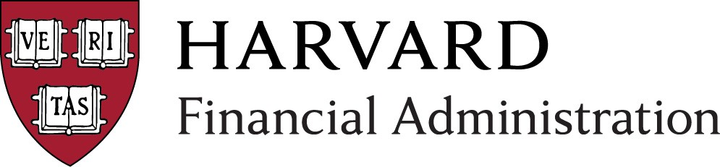
Financial Administration
FY18 Processes & Deliverables Calendar
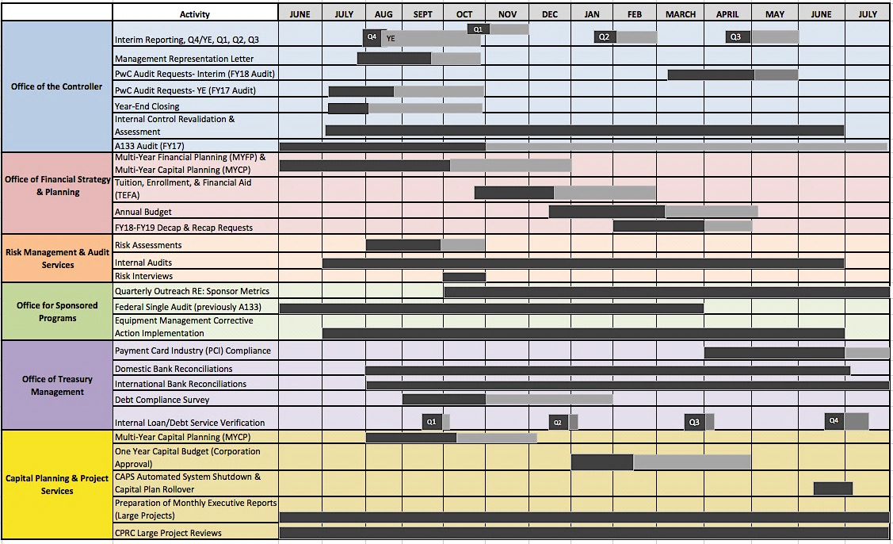
Reference guide only. Dates subject to change without notice.
Updated: August 2017
Activity Range
Follow-Up Range

HUIT/Administrative Technology Solutions (formerly Financial Systems Solutions) – Release Calendar FY18 Update
Activity | Anticipated Start Date | System Outage | Go Live Date | Close Date
GMAS Release (Fall ’17) | 9/22/17 | 9/23/17-9/24/17 | 9/25/17 | N/A
GMAS/FIRST Release (Winter ’17) exact date: TBD | 12/15/17 | TBD | TBD | TBD
GMAS/FIRST Release (Spring ’18) exact date: TBD | 4/1/18 | TBD | TBD | N/A
GMAS/FIRST Release (Summer ’18) exact date: TBD | 7/1/18 | TBD | TBD | N/A
ESTR (IRB) Release exact date: TBD | N/A | 9/1/17 (tentative) | 9/1/17 (tentative) | N/A
ESTR (IRB) Release exact date: TBD | N/A | 12/15/17 (tentative) | 12/15/17 (tentative) | N/A
ESTR (IRB) Release exact date: TBD | N/A | 3/1/18 (tentative) | 3/1/18 (tentative) | N/A
ESTR (IRB) Release exact date: TBD | N/A | 6/1/18 (tentative) | 6/1/18 (tentative) | N/A
ecrt (effort reporting) Release | 6/26/17 | 6/30/17-7/7/17 | 7/7/17 | N/A
ecrt (effort reporting) Release | 1/8/18 | 1/11/18pm (will not affect business hours) | 1/12/18 | N/A
PI Dashboard Summer ’17 Release | 7/28/17 | 7/28/17 (6pm-9pm) | 7/28/17 | N/A
PI Dashboard Fall ’17 Release | 10/27/17 | 10/27/17 (6pm-9pm) | 10/27/17 | N/A
PI Dashboard Winter ’17 Release | 1/26/18 | 1/26/18 (6pm-9pm) | 1/26/18 | N/A
PI Dashboard Spring ’18 Release | 4/27/18 | 4/27/18 (6pm-9pm) | 4/27/18 | N/A
Oracle Financials Platform Improvement (OFPI) Phase 2 Release- FINDINI 4.0.12 Fall 2017 | 6/26/17 | 11/17/17-11/20/17 | 11/20/17 | 12/22/17
Oracle Financials Spring 2018 FINDINI Release- FINDINI 4.0.13 | 1/2/18 | 4/20/18-4/23/18 | 4/23/18 | 4/30/18
HUBS Fall Release (2017) | 11/3/17 | 11/4/17-11/5/17 | 11/6/17 | N/A
HUBS Spring Release (2018) exact date: TBD | 5/18/18 | 5/19/18-5/20/18 (tentative) | 5/21/18 | N/A
Oracle Business Intelligence (OBI) Monthly Releases | 4th Thursday of every month
PeopleSoft Release (48) | 4/14/17 | 9/15/17 (5pm)-9/16/17 (6pm) | 9/17/17 | N/A
PeopleSoft Release (49) | 8/2/17 | 12/1/17 (5pm)-12/2/17 (6pm) | 12/3/17 | N/A
PeopleSoft Release (50) | 10/2/17 | 4/27/18 (5pm)-4/28/18 (10pm) | 4/29/18 | N/A
PeopleSoft Monthly Releases | N/A | Last Thursday (7pm-9pm) | Last Thursday of every month | N/A
CPATH Cloud Migration Discovery and Execution | 7/10/17 | TBD | TBD | N/A
Bottomline Cloud Migration | TBD | TBD | TBD | N/A
Escheat Outsourcing | In process | TBD | TBD

Office of the Controller
Activity | Anticipated Start Date | Anticipated Due Date | Description
Interim Reporting | Q4/YE: 7/31/17  Q1: 10/17/17  Q2: 1/17/18  Q3: 4/16/18 | Q4 / YE: 8/7/17  (Follow-up through 10/26/17)  Q1: 11/2/17  (Follow-­‐up through 11/30/17)  Q2: 1/31/18  (Follow-­‐up through 2/28/18)  Q3: 4/26/18  (Follow-­‐up through 5/31/18) | The quarterly process during which Schools/Units analyze material variances in their interim operating results; they compare: 1) their current year-­‐to-­‐date performance vs. prior year-­‐to-­‐date performance and 2) their projection for the current financial year vs. the budget / most recent quarter. Schools also comment on year-­‐over-­‐year variances in balance sheet items. Q1, Q2 and Q3 quarterly submissions include the reporting template and checklist.  *Note  - The follow up period for Q4/YE extends to FY17 report release date  - The follow up period for Q1 extends from time tubs submit fluxes to end of November.  - The follow up period for Q2 extends from time tubs submit fluxes to end of February.  -The follow up period for Q3 extends from time tubs submit fluxes to end of May.
Management Representation Letter | 7/28/17 | 9/20/2017  (Follow-­‐up through 10/26/2017)  *Note: follow Up Period Extends until FY17 report release date | The annual process during which Senior Management from each School/Unit declares in writing (to FAD and ultimately to the external auditor), to the best of their knowledge, that the financial statements and other presentations are sufficient and appropriate and without omission of material facts to the financial statements. In addition, senior management completes and submits an annual certification of internal controls over financial reporting.
Appendix: Dates and Glossary of Terms FY18 Update

PwC Audit Requests- Interim (FY18 Audit)  PwC Audit Requests- YE (FY17 Audit) | 3/12/2018  7/10/2017 | 5/1/2018  (Follow-up through 5/31/2018)  8/18/2017  (Follow-up through 10/26/2017)  *Note: follow Up Period Extends from PwC's first day of field work to FY17 report release date. | The University is required to have an annual audit of its financial statements. The financial statement audit is done by external auditors, PricewaterhouseCoopers, LLP (“PwC”). This is the annual process during which requests are made to the Schools/Units to provide financial information to PwC, which is used in their audit of the University’s financial statements. PwC may also request to do work at a School/Unit site. The date the financial information is requested will depend on whether the request is for the interim audit or the year-end audit.
Year End Closing | 7/7/17 | 8/2/2017  (Follow-­‐up through 10/26/2017)  *Note: follow up period extends until FY17 report release date | The annual process during which the University completes its financial statement audit and issues its financial report for the fiscal year. This process also includes the final period for processing accounts payable invoices as well as a comprehensive analysis and review of the University’s commitments and contingencies. Analysis is performed to compare finalized results with budgets and interim forecasts.
Internal Control Revalidation  & Assessment | 7/3/17 | 6/29/18 | Some Schools/Units will be asked to validate that key controls from existing internal control processes are operating as designed and to identify any modifications to key controls. Additionally, the OC will continue to assess internal controls for additional business cycles, during which Schools/Units will be expected to participate in internal control discussions, documentation and implementation. The OC will work with financial managers to discuss what financial cycles will be chosen for assessment.
A133 Audit (FY17) | 6/1/17 | 10/31/2017  (Follow-­‐up through 2/15/2018) | The Federal Single Audit includes awards for both Financial Aid and Research Grants. Schools are audited on a rotating basis (usually once every 3 yrs.), with the exception of the College, which is audited every year.

Multi-­‐Year Financial Planning (MYFP) &  Multi-Year Capital Planning (MYCP) | June 2017 | 10/06/17  (Follow-­‐up through December 2017)  Governance review: Corporation/Finance Committee, December 2017 | The annual process during which Schools map out a comprehensive long range financial and capital plan (typically five years) and engage with senior leadership, including the Corporation, on their long-­‐term strategy. Plans include projections of operating revenues and expenses, non-­‐ operating activity and reserves, capital and renewal spending, decaps/recaps to the endowment, and Campaign fundraising.
Tuition, Enrollment and Financial Aid  (TEFA) | Fin Aid Request: Mid September  TEFA: Late October | TEFA: December 15 (follow-­‐up through February 2018)  Governance review (TEFA): Corporation/Finance Committee, February 2018 | The annual process during which Schools propose the following year’s tuition rate and first-­‐year enrollment target; plans are reviewed by the Finance Committee and voted on by the Corporation. The decision-­‐ making process is informed by analyses of total estimated financial aid, the cost of attendance for students (both over time and across peer institutions), trends in program applications and yields, and debt levels of graduating students.
Annual Budget | Budget letter: mid-­‐ November  Budget guidelines: December 15, 2017 | March 2018 (follow-­‐up through April 30)  Governance review: Corporation/Finance Committee, April 2018 | The annual process during which Schools develop their operating budgets for the following year and request approval from the Corporation (based on a recommendation from the Finance Committee). Schools also submit a forecast of current year results and a budget narrative, outlining their goals and challenges, highlighting revenue and expense trends, and noting their progress toward University initiatives.
FY18-FY19 Decap & Recap Requests | February 2018 | March 2018 (follow up through April 2018)  Governance review: Corporation/Finance Committee, April 2018 | The annual process during which Schools request one-time decaps or recaps they plan to utilize, incremental to the annual Treasurer’s distribution. All requests need to be made in accordance with University-wide criteria designed to ensure that decaps do not compromise the long-term purchasing power of an endowment fund. All requests are subject to Corporation approval.

Office of Financial Strategy
& Planning
Activity | Anticipated Start Date | Anticipated Due Date | Description

Risk Management & Audit Services
Activity | Anticipated Start Date | Anticipated Due Date | Description
Risk Assessments | 7/1/2017 | 9/29/2017  (Follow-­‐up through 10/31/17) | An annual risk assessment conducted by each school and central administration unit. Assessments typically include an updated heat map showing risk movement from the prior year, progress on mitigation efforts for top risks, identification of emerging risks, and key actions planned for the upcoming year. Reports are used in monitoring the effectiveness of the University’s institutional risk management program and consolidated for presentation to the University Risk Management Council. Governance review of university risk assessment, Joint Committee on Inspection, December 2017.
Internal Audits | 7/1/2017 | 6/30/2018 | An objective and professional evaluation of a business process, department, critical system or functional operation’s internal control procedures. Through these assurance and consultative activities, RMAS helps University leadership accomplish its objectives by bringing a systematic disciplined approach to evaluate and improve the effectiveness of risk management and control processes. Governance review of audit plan activities for the prior calendar year: Joint Committee on Inspection, February 2018.
Risk Interviews | 10/1/2017 | 10/31/2017 | Annual interviews conducted by RMAS with selected School/CADM leadership team members for the purpose of developing RMAS’ annual internal audit and consulting plan that is submitted to the Joint Committee on Inspection for approval. Discussion will include reference to School/CADM heat map risks in the “strengthen controls” and “audit controls” quadrants; emerging issues (financial, operational, and compliance); new/upcoming initiatives; system and process changes; recent and impending management changes; and strategic direction. Governance review of annual internal audit and consulting plan, Joint Committee on Inspection, December 2017.

Office for Sponsored Programs
Activity | Anticipated Start  Date | Anticipated Due Date | Description
Quarterly Outreach  RE: Sponsor Metrics | Q1-October 2017 | Q4-June/July 2018 | The nature of research finance (RF) work leads to metrics on cash management, reporting, and closeout that is shared regularly by RF Staff with departments and by OSP leadership with School Leadership. These metrics (AR, reporting statistics, and closeout statistics) help Schools to understand an aspect of their research portfolio's performance through a financial and operational lens. Pre- Award Metrics will be incorporated into FY18 Outreach.
Federal Single Audit  (previously A133) | 3/15/17 | 3/31/18 | The Uniform Guidance requires annual audits of States, Local Governments, and Non-Profit Organizations who receive federal funding exceeding $750,000. Harvard University's annual Federal Single Audit (formerly A-133) report covers the entire University. The audit of selected federal awards is done by external auditors, PricewaterhouseCoopers, LLP, with support from RMAS, and is ultimately approved by Harvard. The audit requires significant input from Central, Schools, departments, and faculty. The audit report is due annually by March 31 and is submitted to a Federal Clearinghouse.
Equipment Management Corrective Action Implementation | 7/1/17 | 6/30/18 | OSP has committed to the following steps after a finding on the Federal Single Audit during FY17:  1. Train staff to better understand requirements related to federal equipment.  2. Develop a schedule for completing physical inventories.  3. Investigate equipment management technology.

Office of Treasury Management
Activity | Anticipated Start  Date | Anticipated Due Date | Description
Payment Card Industry (PCI) Compliance | 4/1/18 | 6/30/18  (follow up through 7/31/18) | The annual process whereby the University Credit Card Merchants are required to complete and successfully submit an attestation of PCI Compliance. Process begins in April and University Credit Card Merchants must complete all requirements and submit signed documentation by June 30th to the OTM/Cash Management Office. During the month of July the OTM eCommerce Analyst reviews the merchants’ submissions. Once the Analyst has determined that 100% of merchants are compliant, the OTM analyst completes the University wide SAQ and submits it to Bank of America Merchant Services and American Express, which are due to by EOM July.
Bank Reconciliations | Domestic accounts: due six weeks from close of month | All reconciling items must be cleaned up within 90 days | The monthly process during which Cash Management Office accountants complete and/or review bank to general ledger reconciliations and disseminate findings as appropriate. At year end, Cash Management accountants complete June recons by 1st close then Tubs have until 2nd close to post entries to clean up reconciling items and then any final follow up is done in 3rd close.
International Bank Reconciliations | International accounts: due eight weeks from close of month | All reconciling items must be cleaned up within 90 days | The monthly process during which Tub accountants complete bank to general ledger reconciliations, submits to Tub Finance Office for review & approval and Finance Office submits to Cash Management for final review. From the calendar month end, Tubs have 2 months to submit completed reconciliations with required supporting documentation to Cash Management. Once recons have been submitted to Cash Management they are reviewed for completeness, approved and maintained on file for PWC's annual audit review. Tubs are responsible for making sure any G/L entries are posted for the year-end close, although the reconciliation documentation is due to Cash Management on the regular 8-week schedule.
Debt Compliance Survey | 9/1/17 | 10/31/17  (follow up through 1/31/18) | The annual process whereby Treasury collects information from the schools and units related to activities, which may constitute “private business use” as defined by the IRS. When tax-exempt debt is utilized as a funding source for construction or renovation projects the IRS limits “private business use” within the spaces/buildings funded by this debt. The information is utilized to comply with IRS reporting requirements on Form 990 (Schedule K) of the University’s tax return as well as check overall compliance on all tax-exempt bonds and report this information annually to the CFO.
Internal Loan / Debt Service  Verification | Q1: 9/22/17  Q2: 12/15/17  Q3: 3/23/18  Q4: 6/22/18 | Q1: 9/29/17 (follow-­‐up through 10/6/17)  Q2: 12/22/17 (follow-­‐up through 1/6/18)  Q3: 3/30/18 (follow-­‐up through 4/6/18) Q4: 6/29/18 (follow-­‐up through 7/18/18) | The quarterly process during which OTM calculates quarterly debt service (principal and interest) for the school/unit internal loans. OTM forwards the proposed entries to the schools and units for their review (verification of accounting codes/amounts) prior to uploading them for processing to the general ledger.

Capital Planning & Project Services
Activity | Anticipated Start Date | Anticipated Due Date | Description
Multi-Year Capital Planning  (MYCP) | 8/1/2017 | Submission Deadline: 10/6/17  (Follow-­‐up through 12/4/17)  Governance Review: Corporation/Facilities Committee 12/4/17 | The annual process during which Schools/Units develop multi-year capital spending and funding plans, with detail level evaluation of large projects ($5M plus). This is a revised process for FY18, shifting the five year Capital planning program from the spring of FY18 to fall of FY18; the purpose of which to better align University facilities planning with operating spending and funding requirements for the five year term.
One Year Capital Budget  (Corporation Approval) | 1/1/18 | Submission Deadline: Mid-February 2018  (Follow up through 4/30/18)  Governance Review: Corporation/Facilities Committee 4/30/18 | The annual process during which Schools/Units develop 12-month capital spending and funding plans, requesting recommendation for approval to the Corporation.
CAPS Automated System Shutdown and Capital Plan Rollover | 6/15/18 | 7/5/18 | Annual process of disabling CAPS automated system workflow (including the Project initiation link from CPATH) for two weeks to allow OC/FAR to address necessary end of year accounting entries and adjustments.
Preparation of Monthly Executive Reports (Large Projects) | Monthly | N/A | Monthly preparation of Executive Summary Reports consolidated into single report for EVP
CPRC Large Project Reviews | Monthly | N/A | Monthly committee review of large projects for either EVP or Corporation approval

